

Amarillo, TX
Fax:806-356-0045

RHEUMATOLOGY
REGISTRATION FORM

 |  | PATIENT INFORMATION
Today’s Date: |  |  | Primary Care Physician:
SS#: |  |  | Date of Birth: |  |  | Gender: Male Female
Last Name: |  |  | First Name: |  |  | Middle Initial:
Is this your legal name? Yes No |  |  |  | If not, what is your legal name?
Marital Status: Mr. Miss Mrs. Ms. Single Married Divorced Separated Widow
Mailing Address:
City: |  |  | State: |  |  | Zip:
Home Phone: |  |  |  |  | Cell Phone:
Email:
Would you like to sign up for the patient portal? Yes No
Employer: |  |  | Occupation: |  |  | Employer Phone:
Mailing Address:
City: |  |  | State: |  |  | Zip:
Are you a student? Yes No |  |  | Full Time? |  |  | Part Time?
How did you hear about our practice?
Other family members seen by our practice:

 |  | INSURANCE INFORMATION
Primary Insurance: Policy Holder Information |  |  | Secondary Insurance: Policy Holder Information:
Policy Holder Name: |  |  | Policy Holder Name:
Relationship to Patient: |  |  | Relationship to Patient:
Date of Birth: |  |  | Date of Birth:
Social Security #: |  |  | Social Security #:
Insurance Company: |  |  | Insurance Company:
Ins. Co. Address: |  |  | Ins. Co. Address:
Group # / Contract #: |  |  | Group # / Contract #:
Employee/Cert #: Deductible: $ |  |  | Employee/Cert #: Deductible: $
Financial Responsible Party
Complete this section only if the information is different from the Patient Information Section
Guarantor’s Relationship to Patient: |  |  | Gender: Male Female
Date of Birth: |  |  | SS#:
Last Name: |  |  | First Name:
Address: |  |  | City/State/Zip:
Employer: |  |  | Phone:
Address: |  |  | City/State/Zip:

EMERGENCY CONTACT INFORMATION
PARENT/LEGAL GUARDIAN CONTACT INFORMATION (PATIENTS 18 AND YOUNGER) | EMERGENCY CONTACT INFORMATION  (PATIENTS 18 AND OVER)
Parent/Guardian Name: | Emergency Contact Name:
Address: | Emergency Contact Relation:
City/State/Zip: | Address:
Parent Home Phone: | City/State/Zip:
Parent Cell Phone: | Contact Home Phone:
 | Contact Cell Phone:

PREFERRED PHARMACY CONTACT INFORMATION
PREFERRED LOCAL PHARMACY: | MAIL ORDER PHARMACY:
Name of Pharmacy: | Name of Pharmacy:
Location: | Location:
City/State/Zip: | City/State/Zip:
Phone Number: | Phone Number:
Fax Number: | Fax Number:

ADDITIONAL INFORMATION
We are not required by CMS to collect information on race and ethnicity.
African American American Indian or Native Alaskan Asian Caucasian Hispanic
Native Hawaiian Decline to State Other
Do you have any additional needs or requests?

Patient/Guardian Signature: Date:

Name: DOB:

Please answer all questions to the best of your ability. All the information is kept in the strictest confidence and is for your provider’s use in accessing your total health care needs. If you have any reservations, please feel free to discuss after reading the questions. PLEASE PRINT YOUR RESPONSES. Thank you.

CHIEF COMPLAINT (Reason for appointment):

Indicate the approximate date when these problems started: ______________________________________

PROVIDER HISTORY
Please list any providers or surgeons you have seen in the past and when.
PROVIDER NAME |  |  | REASON/TREATMENT |  |  | DATE
CURRENT MEDICATIONS
Please list ALL the medications you are currently taking, including over the counter medications, vitamins, and supplements. Please use the back of page if necessary.
MEDICINE |  |  |  | STRENGTH | DOSE |  | FREQUENCY

ALLERGIES
Please list any medications or products you have taken which may have caused a true allergic reaction or undesirable side effects (hives, itching, rash, difficulty breathing, muscle aches, cough, nausea etc)
NAME OF MEDICATION | REACTION |  | NAME OF MEDICATION | REACTION

PAST MEDICAL HISTORY:
Please review this sheet and mark any condition you have or have had in the past.
I have reviewed the information on this page and I have no past medical history to report.
ILLNESS | YES | NO |  | ILLNESS | YES | NO |  | ILLNESS | YESSS | NO
Abnormal Heart Rhythm |  |  |  | Enlarged Heart |  |  |  | Liver Disease
Alcohol/Drug Abuse |  |  |  | Fibromyalgia |  |  |  | Lupus
Anxiety |  |  |  | Gastric Reflux |  |  |  | Macular Degeneration
Asthma |  |  |  | Glaucoma |  |  |  | Neuropathy
Bleeding Disorder |  |  |  | Gout |  |  |  | Osteoarthritis
Cancer |  |  |  | Headache |  |  |  | Parkinson’s Disease
Chronic Bronchitis |  |  |  | Heart Attack  Hepatitis: Type_____ |  |  |  | Peripheral Vascular Disease
COPD |  |  |  | Hepatitis type |  |  |  | Psoriasis
Coronary Artery Disease |  |  |  | Hiatal Hernia |  |  |  | Rheumatoid Arthritis
Crohn’s Disease or Ulcerative Colitis |  |  |  | High Blood Pressure |  |  |  | Shingles
Dementia |  |  |  | High Cholesterol |  |  |  | Sleep Apnea
Depression |  |  |  | Hormone Imbalance |  |  |  | Sleep Disorder
Diabetes type |  |  |  | Irritable Bowel Syndrome |  |  |  | Stroke
Diverticulitis |  |  |  | Kidney Disease
Emphysema |  |  |  | Kidney Stones

PAST SURGERIES/SERIOUS ACCIDENTS
Please list all surgeries or serious accidents you have had in the past.
SURGERY | DATE |  | SURGERY | DATE

PAST HOSPITALIZATIONS
Please list all hospitalizations, reason, and date you have had in the past.
HOSPITALIZATION | REASON | DATE

FAMILY HISTORY
FAMILY | AGE  (Or Age At Time Of Death) | HEALTH CONDITION(S)  Please list any diseases which tend to run in the family, such as high blood pressure, heart disease, diabetes, cancer, gout, asthma, stomach ulcers, epilepsy, tuberculosis, cystic fibrosis, muscle disease, stroke, or thyroid disease.
FATHER
MOTHER
BROTHER
SISTER
FAMILY

SOCIAL HISTORY
What type of occupation do (or did) you have?
Current employment status:
How many children do you have? # Girls # Boys
Marital Status: Mr. Miss Mrs. Ms. Single Married Divorced Separated Widow
Education: Elementary High School College Graduate School
HABITS
Have you ever smoked cigarettes regularly? Yes No | Currently smoking? Yes No
If yes, how many packs per day? | How many years?
Are you thinking about quitting? Yes No | Date you quit smoking?
Do you use snuff or chewing tobacco? Yes No | If so, how much?
Do you drink alcohol? Yes No | If so, what type?
How many drinks in a day? | How many years?
Do you have any drug, nicotine, or alcohol habits that concern you? Yes No
Do you regularly use sleeping pills, tranquilizers, or painkillers? | If yes, which ones?
Do you currently use marijuana, cocaine, or other “recreational” drugs? Yes No | If yes, which ones?
Do you drink caffeinated beverages? Yes No | How many daily?

IMMUNIZATIONS
Please indicate when received
Flu Vaccine: | Pneumonia Vaccine:
Shingles vaccine: | HPV (Gardasil) Vaccine Series:
Tetanus Vaccine: | COVID Vaccine:
RSV Vaccine:

GENERAL HISTORY
What is your current weight? |  | Has it changed in the past 6 months? Yes No
How much? | Up or down? | Intentional? Yes No
Has anyone in your family or immediate company been sick recently? Yes No
Do you follow a special diet? Yes No |  | Type:
Do you exercise regularly? Yes No |  | What type and how often?
If you served in the military: Were you ill while in the military? Yes No
If so, what was the nature of the illness?
Did you serve overseas? Yes No |  | If so, when and where?
Have you traveled out of the country in the past year?  Yes No |  |  | If so, please list the places you have been.
Please list all pets or any other animals which you may have been in contact within the past year:

MALE
Screening | Date | Abnormal findings
Prostate Cancer (PSA)
Men 55-69 if average risk
Abdominal Aorta Aneurysm
Men 65-75 who have smoked at least 100 cigarettes in their lifetime; one-time screening by ultrasound.
HIV screening
All adults over the age of 18 should be screened once in their lifetime, more often if high-risk factors.
Hepatitis C Screening (HCV)
All adults 18-79 once in a lifetime; more often if high risk factors.
Lung Cancer
Low radiation dose CT scan in adults aged 50-80 who have a 20-pack-year smoking history.
Colon Cancer Screening (Colonoscopy or at-home tests)
Age 45+, or sooner if family history
Osteoporosis (DEXA; bone density)
Age 70+, or <70 if high risk factors.
FEMALE
Screening | Date | Abnormal findings
Breast Cancer (Mammogram)
Age 40-75, yearly or every 2 years
Cervical Cancer Screening (PAP Smear)
Age 21-65 with cytology alone every 3 years OR cytology plus high-risk HPV every 5 years.
HIV screening
All adults over the age of 18 should be screened once in their lifetime, more often if high-risk factors.
Hepatitis C Screening (HCV)
Lung Cancer
Low radiation dose CT scan in adults aged 50-80 who have a 20-pack-year smoking history.
Colon Cancer Screening (Colonoscopy or at-home tests)
Age 45+, or sooner if family history
Osteoporosis (DEXA; bone density)
Age 65+, or <65 if high risk factors.

PLEASE CHECK ALL THAT CURRENTLY APPLY TO YOU
SKIN: |  |  | GASTROINTESTINAL: |  |  | MUSCULOSKELETAL:
Change in skin coloration |  |  | Abdominal pain |  |  | Back pains
Recent change in hair distribution |  |  | Black stools |  |  | Bone pains
Recurrent itching |  |  | Blood in stools |  |  | Joint pains
Recurrent rash or eruptions |  |  | Becoming nauseated after meals |  |  | Joint stiffness
HEAD, EARS, NOSE, THROAT: |  |  | Change in appetite |  |  | Joint swelling
Bad teeth |  |  | Change in bowel habits |  |  | Muscle aches
Deafness |  |  | Change in stool color |  |  | NEUROLOGICAL:
Dizziness |  |  | Constipation |  |  | Arm or leg numbness
Headaches more than once a week |  |  | Diarrhea |  |  | Arm or leg weakness
Nasal discharge/sinus trouble |  |  | Getting full quicker than usual |  |  | Change in speech
Nosebleeds |  |  | Have pain when moving bowel |  |  | Drowsiness
Ringing in ears |  |  | Have you ever had an ulcer |  |  | Seizures
Trouble/pain when swallowing water/food |  |  | Heartburn |  |  | Tremors
Visual disturbances (double vision, blurred vision, or loss of vision, etc) |  |  | Hemorrhoids |  |  | PSYCHIATRIC:
RESPIRATORY: |  |  | Increased abdominal gas |  |  | Difficulty making decisions
Chest colds more than twice/week |  |  | Intolerance to certain foods |  |  | Ever considered or attempted suicide
Coughing up blood |  |  | Mucus or pus in stool |  |  | Hard to concentrate or remember
Difficulty Breathing |  |  | Nausea and/or vomiting |  |  | Often cry for no reason
Exposure to TB |  |  | Rectal pain |  |  | Often lonely or depressed
Night sweats |  |  | Vomiting up blood |  |  | Tired most of the time
Previous abnormal chest x–rays |  |  | Yellow jaundice |  |  | Trouble sleeping
Recurrent cough |  |  | GENITOURINARY: |  |  | HEMATOLOGIC:
Shortness of breath when walking |  |  | Brown, bloody, or cloudy urine |  |  | Anemia
Wheezing/Asthma |  |  | Burning when you urinate |  |  | Blood transfusions
CARDIAC: |  |  | Constant feeling you have to urinate |  |  | Lymph gland swelling
Ankles and feet swell |  |  | Ever had a sexually transmitted disease |  |  | Swelling in armpits or groin
Been told you have a heart murmur |  |  | Frequency in urination |  |  | Tendency to bruise or bleed easily
Been told your heart is enlarged |  |  | Losing urine when you cough, sneeze or lift heavy objects
Blacked out and fell to floor |  |  | Trouble starting/stopping urine |  |  | WOMEN ONLY:
Chest pain, tightness, or pressure |  |  | Sexual difficulty |  |  | Abnormal vaginal bleeding
Distress in chest with exertion |  |  | Waking at night to urinate |  |  | Breast lump(s)
Irregular heartbeat |  |  | ENDOCRINE: |  |  | Breast tenderness
Pain or cramps in leg when walking |  |  | Chills |  |  | Vaginal itching or discharge
Rapid heartbeat |  |  | Eating more and losing weight |  |  | Age when you had your first period?
Rheumatic fever |  |  | Excessive thirst |  |  | Periods last how many days?
Shortness of breath when lying flat |  |  | Fever |  |  | Date of your last menstrual cycle?
Waking at night short of breath |  |  | Heat or cold intolerance |  |  | Menopausal? Yes No (CIRCLE ONE)
 |  |  | Increase in hair
 |  |  | Recent swelling in the neck |  |  | MEN ONLY:
 |  |  | Swelling in face and hands |  |  | Burning or itching from penis
Please list any additional conditions not shown above: |  |  |  |  |  | Painful testicles
 |  |  |  |  |  | Swelling or lumps on testicles
 |  |  |  |  |  | Trouble getting or maintaining an erection

____________________________________ ________________
PATIENT SIGNATURE DATE

____________________________________ ________________
PHYSICIAN SIGNATURE DATE

PAIN ASSESSMENT BODY DIAGRAM
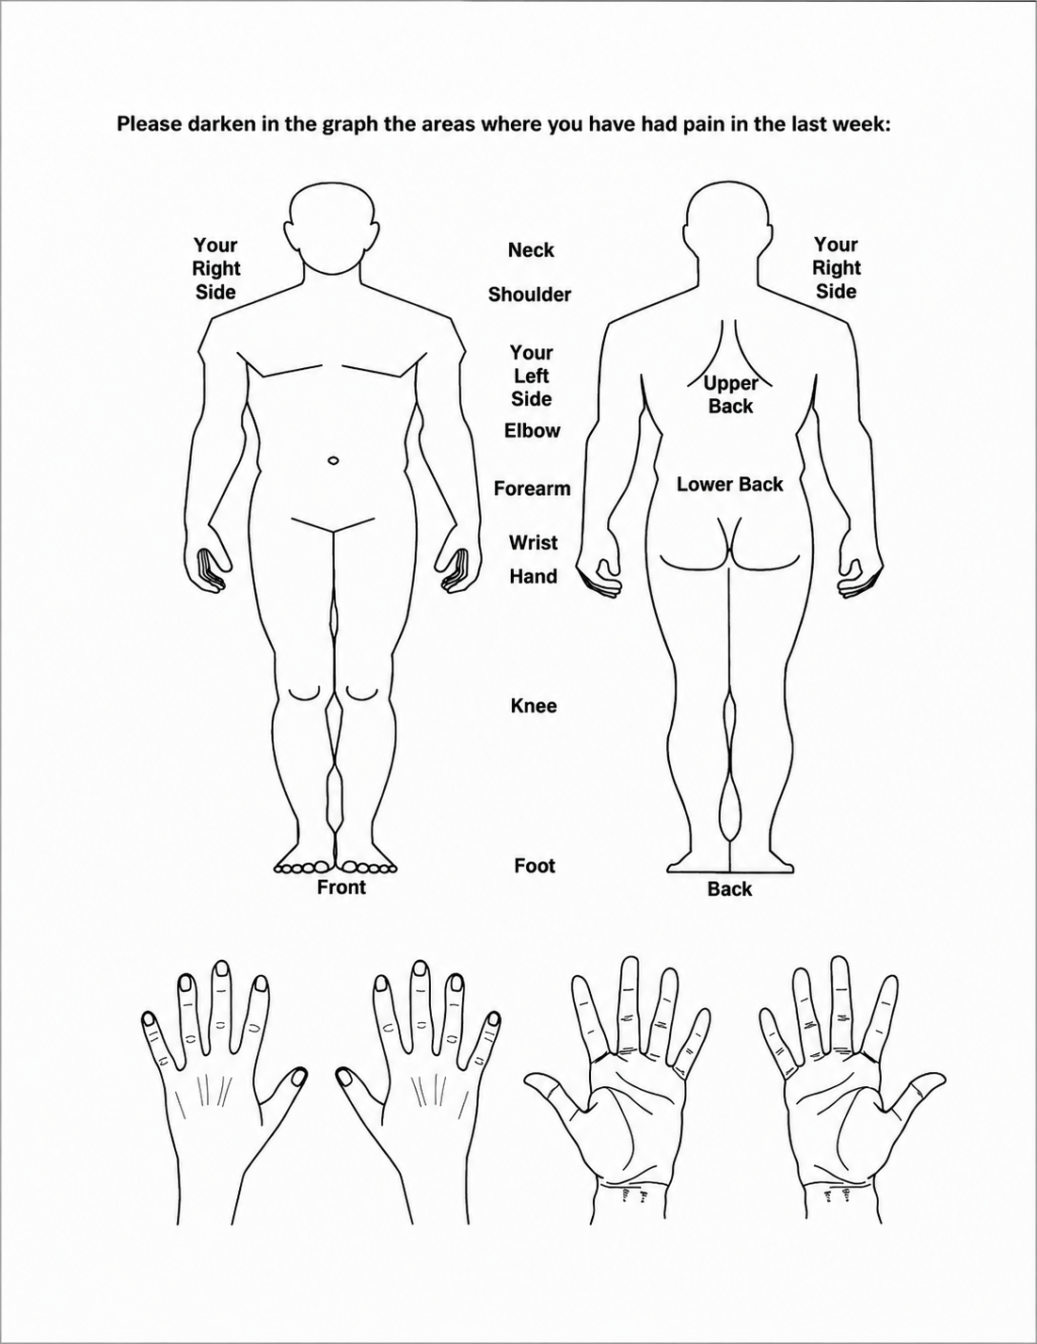

CANCELLATION/ NO SHOW POLICY FOR APPOINTMENTS

We understand that there are times when you must miss an appointment due to emergencies or obligations for work or family. However, when you do not call to cancel an appointment, you may be preventing another patient from getting much needed treatment. Conversely, the situation may arise where another patient fails to cancel and we are unable to schedule you for a visit, due to a seemingly “full” appointment book.

Out of courtesy, you will receive a reminder call the day before your scheduled appointment. At each appointment, you will also receive an appointment card with detailed information about your next appointment. We also have our answering service that is available to take calls 24 hours a day 7 days a week.

If an appointment is not cancelled at least 24 hours in advance you will be charged a One Hundred Dollar ($100) fee; this will not be covered by your insurance company and must be paid prior to rescheduling.

AFTER THREE NO SHOW APPOINTMENTS, YOU MAY BE DISCHARGED AS A PATIENT.

SCHEDULED APPOINTMENTS

We understand that delays can happen; however, we must try to keep our other patients and doctors on time.

If you arrive 15 minutes past your scheduled appointment time, per doctors’ discretion you may be asked to reschedule.

I understand and agree to the above mentioned policy.

Printed Name:

Signature:

Date:

HEALTH INFORMATION EXCHANGE (HIE)

It is a database where records are electronically stored. Doctors can sign into this database and see records from other doctor’s you have seen in the past.

Only doctors you are currently seeing are allowed to access this database. Emergency rooms in Amarillo are set up on the database.

This database is Health Insurance Portability and Accountability Act (HIPPA) approved.

Printed Name:

Signature:

Date:

CONSENT TO TREAT, RELEASE OF INFORMATION, AND FINANCIAL RESPONSIBILITY

I hereby consent to receive medical and health care services provided by Amarillo Medical Specialist physicians, employees, and such associates, assistants, and other health care providers as my physicians deem necessary. I understand that such services may include diagnostic procedures, examinations, images, and treatment.

I understand that this consent to treatment will be valid and remain in effect as long as I attend AMS unless revoked by me in writing.

AMS may disclose all or any part of my medical record (including oral information) and may provide bills/invoices to any person, corporation or agency (or their authorized representative) which is or may be liable under a contract to AMS, or to me or my family members for all or part of the charges including, but not limited to hospital or medical service companies, insurance or third party payors, workers compensation carriers, or my employer and any individual or entity designated by me as a guarantor or party responsible for payment of fees for health care services provided to me.

I understand and agree that the information I am authorizing to be released may include AIDS/HIV test results, diagnosis, treatment and related information; information about drug and alcohol use and treatment; and mental health information.

I understand that I may revoke this authorization at any time by providing written notice to AMS, except to the extent that action has been taken in reliance on it. Unless earlier revoked this authorization expires automatically 90 days after the last AMS visit or after all insurance or third-party claims have been paid or satisfactorily resolved, whichever occurs last.

Release of Liability: I release and agree to hold harmless AMS and its agents, representatives, and employees from any and all liability associated with the release of confidential patient information in accordance with this authorization. I understand AMS cannot be responsible for use or redisclosure of information by third parties.

Financial Responsibility and Assignment of Benefits: In consideration for receiving medical or health care services, I hereby assign my right, title, and interest in all insurance, Medicare/Medicaid, or other third party payor benefits for medical or health care services otherwise payable to me to AMS physicians and or my insurance company or other third party payor, up to the total amount of my medical and health care charges, to AMS physicians and or Medical Practice Income Plan. I certify that the information I have provided in connection with any application for payment by third party payors, including Medicare/Medicaid is correct.

I agree to pay all charges for medical and health care services not covered by or which exceed the amount estimated to be paid or actually paid by Medicare/Medicaid, my insurance company, or other third-party payor and agree to make payment as requested by AMS.

I certify that this form has been fully explained to me, that I have read and understood its contents.

Printed Name:

Signature:

Date:
HIPAA NOTICE OF PRIVACY PRACTICES

ACKNOWLEDGEMENT AND REQUESTED RESTRICTIONS

By signing below, you acknowledge that you have received this Notice of Privacy Practices prior to any service being provided to you by the Practice, and you consent to the use and disclosure of your medical information as set forth herein except as expressly stated below.

Patient Name: Date of Birth:

- Please list the family members and/or other person, if any, whom we may inform about your general medical condition and your diagnosis (including treatment, payment, and health care operations):

Name Relationship Phone Number

Name Relationship Phone Number

Name Relationship Phone Number

- Please list the family members and/or other persons, if any, whom we may inform about your medical condition ONLY IN AN EMERGENCY:

Name Relationship Phone Number

Name Relationship Phone Number

Name Relationship Phone Number

- Please list the telephone number(s) where you want to receive calls or text about your appointments, lab, x-ray results, and any additional health care information:

- Can confidential messages (for example, appointment information) be left on your answering machine?
Yes No

SIGNATURES:

Patient/Legal Representative: Date:

If Legal Representative, Relation to Patient:

Witness (optional): Date:

LABORATORY AND RADIOLOGY RESULTS POLICY

Laboratory and radiology results require a minimum of seven (7) days to be available in our office. This allows time for the provider to personally review ALL results.

We encourage you to sign up for the web-based patient portal if you have internet access. Once your test results are reviewed, they will be available to view on the patient portal.

Our office will call you with any abnormal test results. Normal results will not be called on.

I understand and agree to the above mentioned policy.

Printed Name:

Signature:

Date:

PATIENT PORTAL

We ask that you please utilize the patient portal for refills, appointment changes, and updates.

However, if medical advice is given, medications are prescribed or changed, per the doctor's discretion, you may be subject to a fee for telehealth rather than an in office visit or charge of twenty-five to thirty-five dollars ($25-35).

I understand and agree to the above mentioned policy.

Printed Name:

Signature:

Date:
REQUEST FOR RELEASE OF MEDICAL RECORDS

Date:

Records requested from: _____________________________________________________________________

Primary Care Physician/Clinic/Hospital

Address:

Phone:

Fax:

to the following person(s):

Amarillo Medical Specialists
Amarillo, TX
Phone:
Fax: 806-356-0045

Full Name:

Other Name(s) Used: Date of Birth:

Address:

City: State: Zip Code:

Phone:

Signature:

